CIS 6035
Development Project
Project Proposal

Name – M. Heshika Nilukshi Fernando
Student ID – GM/BSCSD/06/07 (20283425)
- Title
AI-Powered English Learning Web Application for Spoken English and School Curriculum Education.

- Introduction
In recent years, online learning platforms and digital education systems have transformed traditional education methods worldwide. Many students now use web-based applications to access lessons, learning materials, and assessments from anywhere. In the field of English education, online spoken English and school curriculum learning platforms are becoming increasingly popular due to the growing importance of English for education, communication, and employment.
At the same time, Artificial Intelligence (AI) and Machine Learning technologies are emerging trends in modern education. AI-based systems are now used for automated grading, intelligent learning, and providing quick feedback to students. These technologies help reduce teachers’ workload and improve learning efficiency. (Norvig, 2021)
However, many existing English learning platforms mainly provide videos and notes while lacking intelligent assessment features. Teachers still spend a large amount of time manually checking written answers and giving feedback. To address these issues, this project proposes the development of an AI-powered English learning web application that combines online learning, course management, and automated answer evaluation into a single platform.

- Current situation leading to problem identification
Currently, many English learning platforms mainly focus on either Spoken English courses or school curriculum education separately. There are very few systems that combine both Spoken English learning and school syllabus education within a single platform. Because of this, students often need to use multiple websites or attend different classes to meet their learning needs.
Most existing systems mainly provide video lessons and downloadable notes but lack interactive features such as online tests, progress tracking, and intelligent assessment methods. In addition, many platforms only support Multiple Choice Question (MCQ) tests and do not provide AI-based evaluation for written answers.
Teachers still spend a large amount of time manually checking students’ written papers and giving feedback. This increases workload and delays the evaluation process. Furthermore, there are limited English learning systems that integrate course management, online learning, payment handling, and AI-powered answer checking into one centralized platform.
Therefore, there is a need for an AI-powered English learning web application that combines Spoken English courses, school curriculum learning, online testing, and automated answer evaluation within a single system.

- Proposed technique to solve the current problem
The proposed solution is an AI-powered English learning web application that combines Spoken English courses, school curriculum education, online assessments, and automated answer evaluation within a single platform. The system will support three main users: Students, Teachers, and Administrators.
The platform will include two main sections: Spoken English courses (Beginner, Intermediate, Advanced, and Business English) and School Curriculum lessons for Grades 6–11 and A/L students. After completing payments, students can access video lessons, tutorials, quizzes, and assignments related to their selected course or grade.
The system will be developed using React for the front end, Node.js and Express.js for the backend, and MySQL as the database. The application will follow a three-tier architecture for better performance and management.
The main innovative feature is the AI-based answer checking module. Students can upload written answers, and the AI system will evaluate them using Natural Language Processing (NLP) and text similarity techniques by comparing answers with teacher-provided model answers and keywords. The system will then generate marks and feedback automatically, reducing teachers’ manual workload and improving evaluation efficiency. (Martin, 2023)
Additionally, the platform will include online quizzes, payment management, progress tracking, and separate dashboards for students, teachers, and administrators.

- Feasibility

The proposed AI-powered English learning web application is technically, economically, and operationally feasible using modern web and AI technologies. The system will be developed using React for the frontend, Node.js/Express.js for the backend, MySQL for database management, and Python-based AI libraries for the machine learning module. These technologies are widely available and suitable for this type of project. (Meta Platforms, 2026)
- Technical Feasibility
The required technologies are well-established and supported by strong documentation. The developer has sufficient knowledge in web development and basic AI concepts to implement the system, including the NLP-based answer checking module.
- Economic Feasibility
The project is low-cost since most tools such as React, Node.js, Python, and MySQL are open source. Only basic hardware and internet access are required, making it financially feasible.
- Time Feasibility (Development Schedule)
The system can be completed within the academic timeframe by following a structured development plan, including design, development, testing, and documentation phases.
- Operational Feasibility
The system is user-friendly and suitable for students, teachers, and administrators with basic computer skills. The interface will be simple and easy to use for managing courses, tests, and AI-based evaluations.
- Legal Feasibility
The system will ensure data privacy and secure handling of user information. All content will be used ethically for educational purposes, and the AI system will support learning and assessment in a responsible manner.
6. Project Description
The proposed system is an AI-powered English learning web application designed to support Spoken English learning and School Curriculum education within a single platform. The system is divided into three main user roles: Student, Teacher, and Administrator, each with specific functionalities and access levels.
Student Module
Students can register and log in to the system, browse available courses, and enroll in either Spoken English or School Curriculum programs. After payment confirmation, students can access video lessons, downloadable tutorials, and practice materials. They can also attempt online quizzes and a public test section available without registration. Additionally, students can upload written answers for assignments, where the AI system evaluates their responses and provides marks and feedback.
Teacher Module
Teachers can log in to the system and manage educational content. They are responsible for uploading video lessons, tutorials, and creating quizzes and assignments for different courses and grade levels. Teachers can also upload model answers or marking schemes, which will be used by the AI system for evaluation. In addition, teachers can monitor student progress and review AI-generated results.
Admin Module
The administrator manages the overall system, including user accounts, course management, and payment verification. Admins can add or remove teachers and students, approve course content, and control access to different learning materials. They also oversee system activity and ensure smooth operation of the platform.
System Features and Behavior
The system includes two main learning sections: Spoken English (Beginner, Intermediate, Advanced, Business) and School Curriculum (Grades 6–11 and A/L). All content is delivered through a structured web interface with secure login and role-based access control.
The platform also includes an AI-based answer checking module, which processes student-submitted written answers using Natural Language Processing (NLP) techniques. The AI compares answers with teacher-provided model answers and generates marks and feedback automatically. This reduces manual grading work and improves assessment efficiency.
Overall, the system provides a centralized, intelligent, and interactive learning environment that integrates learning, testing, and evaluation in one platform.

7. Deliverables
The project will produce the following key deliverables:
Software Deliverables
- Fully functional AI-powered English learning web application
- Student, Teacher, and Admin dashboards
- Spoken English and School Curriculum modules
- Online quizzes and test system
- AI-based answer checking system
Technical Deliverables
- Complete source code (frontend, backend, AI module)
- MySQL database design and implementation
- System integration of all modules
Documentation Deliverables
- System design diagrams (architecture, database, modules)
- Final project report
- User manual for all users
Testing Deliverables
- Test cases and testing report
- AI evaluation performance results
- System validation and feedback summary

8. Resources Required
Software Tools
- Visual Studio Code (or any IDE)
- Node.js and Express.js (backend development) (Node.js Documentation)
- React.js (frontend development)
- MySQL (database management system) (MySQL Reference Manual)
- Python (AI module development)
- TensorFlow / Scikit-learn (machine learning libraries) (TensorFlow Documentation)
- NLP libraries (for text analysis and answer checking)
- Postman (API testing)
- GitHub (version control) (GitHub)

Hardware Requirements
- Personal computer or laptop (minimum i5 processor recommended)
- Minimum 8GB RAM
- Stable internet connection
- Storage space for project files and database

Additional Requirements
- Dataset of sample English answers (for AI training and testing)
- Teacher-provided marking schemes and model answers
- Web browser for testing and deployment (Chrome/Firefox)

9. Expected Output and Outcome
Expected Output
The project will produce a fully functional AI-powered English learning web application that includes Spoken English courses, School Curriculum learning materials, online quizzes, and an AI-based written answer checking system. The system will also provide separate dashboards for students, teachers, and administrators to manage learning activities efficiently.
Expected Outcome
The system is expected to improve the overall English learning experience by making education more accessible, interactive, and efficient. Students will benefit from instant feedback on their answers through the AI evaluation system, while teachers will experience reduced workload in marking written papers. Overall, the platform will enhance learning efficiency, improve student performance, and modernize traditional English education methods through the use of Artificial Intelligence.

10. Time Plan for Implementation
The project will be completed within 10 weeks with a structured development plan to ensure proper design, implementation, testing, and delivery.
Week 1: Requirement analysis and system study (identify features, user roles, and problem analysis)
Week 2: System design (UI/UX design, database design, and architecture planning)
Week 3: Frontend development setup (React structure and basic pages for Student, Teacher, Admin)
Week 4: Backend development setup (Node.js/Express APIs, authentication, and database connection)
Week 5: Implementation of core modules (user management, course management, and role-based access)
Week 6: Spoken English and School Curriculum modules development (courses, videos, and tutorials)
Week 7: Online test and quiz system development (MCQs and practice tests)
Week 8: AI-based answer checking module development (NLP integration and evaluation system)
Week 9: System integration, testing, and bug fixing (full system testing and improvements)
Week 10: Final documentation, evaluation, and project submission preparation
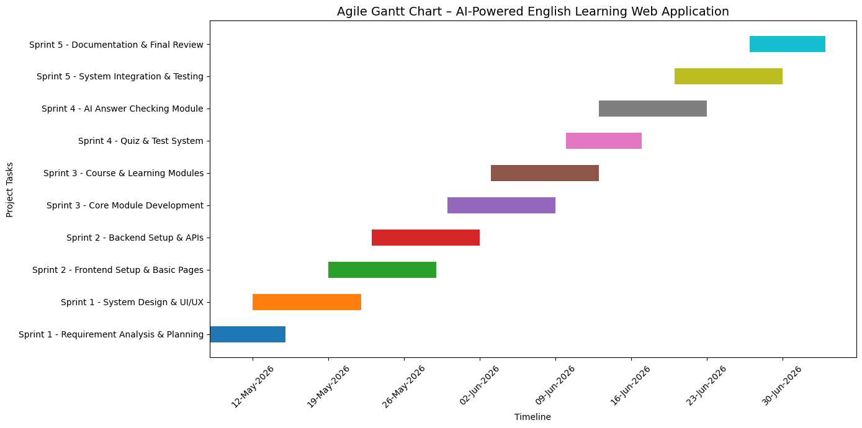

Figure 1 Gantt chart

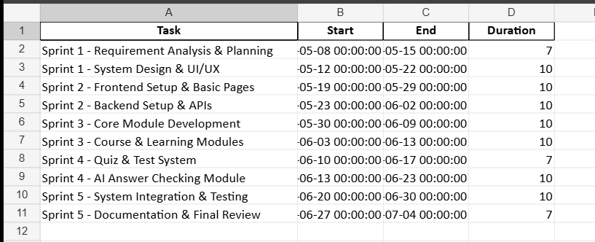

Figure 2agile_gantt_chart_schedule.xlsx

11. Limitations
The proposed AI-powered English learning web application has several limitations that may affect its performance and scope.
One of the main limitations is the accuracy of the AI-based answer checking system. Since Natural Language Processing (NLP) is used to evaluate written answers, the results may not always be 100% accurate, especially for complex or creative student responses. The system may sometimes misinterpret answers compared to human evaluation.
Another limitation is the dependency on quality training data. The effectiveness of the AI model depends on the availability of well-structured sample answers and marking schemes provided by teachers. Poor or limited data may reduce the accuracy of evaluation results.
Time constraints are also a limitation, as the project must be completed within an academic timeframe. This may restrict the development of more advanced features such as real-time speech recognition for spoken English or advanced analytics dashboards.
In addition, the system requires a stable internet connection to access learning materials, videos, and AI evaluation features. Students with poor connectivity may face difficulties in using the platform effectively.
Finally, the system mainly focuses on English language learning, so it does not cover other subjects, which limits its scope as a specialized educational platform.

12. References
GitHub. (n.d.). Retrieved from GitHub: https://github.com/
Martin, D. J. (2023). Speech and Language Processing (3rd ed.). Hoboken, New Jersey, USA: Pearson Education.
Meta Platforms, I. (2026). React Official Documentation. Retrieved from React.dev: https://react.dev/
MySQL Reference Manual. (n.d.). Retrieved from MySQL: https://dev.mysql.com/doc/
Node.js Documentation. (n.d.). Retrieved from Node.js: https://nodejs.org/
Norvig, S. R. (2021). Artificial Intelligence: A Modern Approach. Hoboken, New Jersey, USA: Pearson Education.
TensorFlow Documentation. (n.d.). Retrieved from TensorFlow: https://www.tensorflow.org/

